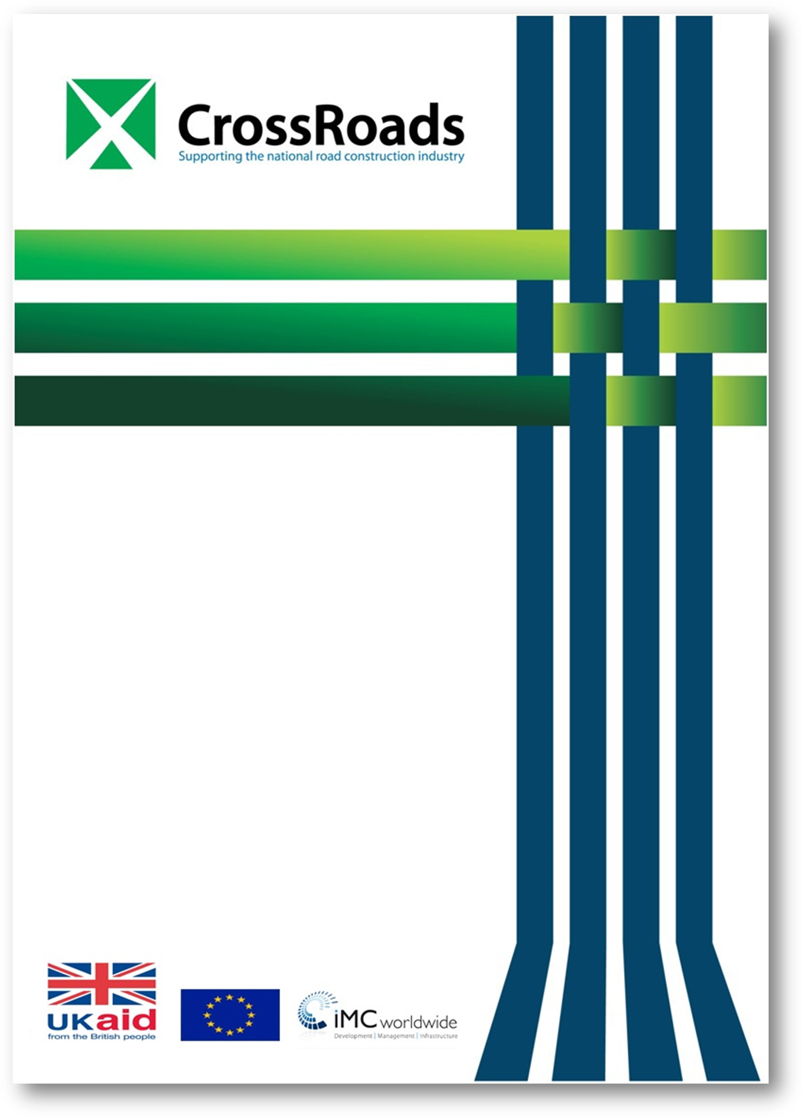

Project Title
Roll-Out of Primary 1 to Primary 4 Road Safety Education Curriculum in Ugandan Schools

Creating Opportunities for Sustainable Spending on Roads in Uganda

Completion Report
Prepared by:
Uganda Road Accident Reduction Network Organisation (URRENO)
30th July 2014

Acknowledgements

On behalf of the management and members of the Uganda Road Accident Reduction Network Organisation (URRENO), we would like to submit our final project report that gives detailed highlights of all the activities and results of the Roll-Out of Primary 1 to Primary 4 Road Safety Education Curriculum in Ugandan Schools. As we come to the completion of this project, we have learnt a number of lessons, and further reached out to those children who did not have an opportunity to be reached before.

We extend our gratitude to our partners the CrossRoads Challenge Fund, the donors – European Union (EU) and UKaid– for their support that enabled us to fully implement this project and, most importantly, to save the lives of Ugandan children that would otherwise be lost on the roads.

We thank our partners, the National Curriculum Development Centre (NCDC), for the technical support they provided during the development and implementation of this project and for the long-term partnership we have had with them since 2008. Our appreciation goes to all the CCTs, teachers and school administrators for their cooperation and efforts in the implementation of the project.

Table of Contents

Acknowledgements 1
Executive Summary 4
Introduction 6
Background Information 6
1.2 Project Summary 7
1.2.1 Identified needs 7
1.2.2 Objectives 7
1.2.3 Relevance 8
1.2.4. Project approach 8
1.2.5. Main activities 8
1.2.6 Expected outputs/outcomes 9
1.2.7 Beneficiaries 9
2.0. The Innovation 11
2.1 The Road Safety Innovation 11
2.2. Difference between the Current and Past Initiatives 12
2.3 Innovative Methods 12
3.0 Methodology 13
3.1. Design of the Study 13
3.1.1 Extent and coverage of the project 13
3.2. Key Factors Considered 13
3.3. List of Relevant Literature and Documents Reviewed 14
3. 4. Activities Workplan 14
3.4.1 Road safety education forum 14
3.4.2 Training of trainers 15
3.4.3 Developing the trainers’ manual, printing and distribution of source materials 15
3.4.4 Training of teachers 16
3.4.5 Teaching children road safety 16
4.0 Presentation of Findings and Discussions 17
Training of CCTs 17
Baseline Assessment for Teachers’ Training Needs 17
Production of Road Safety Materials 18
Training of 720 Teachers 18
Road Safety Advocacy Forums 18
URRENO Part of the CISCOT 19
Road Safety Education in 180 Primary Schools Countrywide 19
Sustainability of Road Safety Education 20
Summary of Key Outputs 21
5.0 Conclusions and Recommendations 22
5.1 Challenges and Recommendations 22
5.2 Lessons Learned and Conclusions 22
5.3 Recommendations 22

Annexes 24
1) Inception Report
2) Baseline Report
3) First Stakeholders Forum Report
4) Second Stakeholders Forum Report
5) Training Needs Assessment Report
6) Teacher Training Report
7) List of teachers interviewed and schools visited during monitoring and evaluation
8) The number of children reached out by school and class
9) List of CCTs trained
10) List of teachers trained
11) List of materials produced

Executive Summary
Uganda, like many other countries in Africa, has a serious road safety problem. Ensuring road safety for all road users remains a challenge and the number of recorded fatalities and injured owing to road accidents remains unacceptably high. 2,937 people have died and 15,752 injured due to road accidents in 2013 according to Uganda Police Traffic and Crime report.

However, the actual size of the problem is likely to be greater than this because of significant under-reporting of accidents, a problem known to exist in many low- and middle-income countries. Many road accident victims are working men and women whose families often depend on their income; as a consequence the social cost of accidents often goes far beyond the simple statistics of those actually involved. In addition, such accidents in Uganda are known to put a considerable strain on an already overstretched health service – and are likely to ‘cost’ the economy around 1 – 2 % of GDP. While some road safety measures can be expensive, they can also be shown to be cost-effective. However, it is recognised that road safety often has a lower priority than it possibly deserves among practitioners and other stakeholders in many countries.

Following the passage of the 1998 Traffic and Road Safety Act, the Government of Uganda, with assistance from the World Bank, began a Road Safety Audit and Improvement Study which, alongside a three-year Road Safety Action Plan, focused on capacity-building and institutional support. On the basis of this study, the Production of Engineering Manuals, Specifications and Provision of Institutional Support Project (PEMSIS) were designed to implement most of Phase 1 of the three-year Road Safety Action Plan. The PEMSIS project had four main components, including education, capacity-building, crash data, and safety audit and health. The education component involved developing a Road Safety Education (RSE) curriculum, producing an up-to-date Highway Code, and developing a novice driver training curriculum, among others. After the Road Safety Education curriculum was developed, it was incorporated into the primary school syllabus for Primary 1 to Primary 4 and it became government policy to teach road safety in primary schools.

The need to roll out the RSE curriculum to primary schools all over Uganda was deemed to be the solution to road accidents involving school children. However, because the requisite funds were not available, the government had to wait for a while to implement the project. As a result, the roll-out of the curriculum never took place until July 2013 when the Roll-out of Primary 1 to Primary 4 Road Safety Education Curriculum in Ugandan Schools Project began with funding from UKaid and the European Union through the Crossroads Challenge Fund. The project targeted 180 primary schools along highways and in urban centres that are considered to be more prone to road accidents.

The roll-out of the RSE curriculum had four main components:

- Advocacy (road safety stakeholders’ forums)
Two forums were organised by the Uganda Road Accident Reduction Network Organisation (URRENO) for two reasons:
- To inform stakeholders in the RSE project that was to be undertaken, to seek their input for the successful implementation of the project and to advocate the promotion of RSE, starting with schools.
- To inform stakeholders about the achievements and success so far attained after the implementation of the project. The forum gathered recommendations for the continuity of RSE in the rest of the schools in Uganda.
- Training of CCTs
Thirty Centre Coordinating Tutors (CCTs) were selected from 10 Core Primary Teachers Colleges (PTCs) and instructed in a road safety training-of-trainers (ToT) programme. The four-day training covered the RSE background information, the actual content of safe road use and instructional methods and materials for teaching road safety.
- Producing RSE resource materials
The project produced and distributed a training manual, teacher’s guides, a learner’s text, posters and a video to 180 primary schools in nine regions of Uganda.
- Training of teachers
A total of 720 classroom teachers from the selected 180 schools were trained in teaching road safety for Primary 1 to Primary 4.

The report also provides a detailed presentation of the methodology applied in the implementation of the project, an analysis of road safety education findings and the challenges encountered. Finally, a series of recommendations regarding road safety education initiatives are considered. These initiatives are urgently needed in Uganda to improve road use behaviour, especially among school-going children.

1.0 Introduction

1.1 Background Information
An efficient and safe transport system is a prerequisite for the economic and social transformation of any society. Uganda’s national transport system currently comprises road, rail, air and water transport modes and road transport accounts for 96.5 % of the freight cargo whereas the rest accounts for 3.5 %.

There have been a number of significant reforms in the roads sub-sector in the recent past, and most notable among these has been the separation of roles and responsibilities with respect to policy formulation, road development and maintenance, regulation and financing. This has resulted in the creation of the Uganda National Roads Authority (UNRA), which is responsible for the development and maintenance of national roads, and the Uganda Road Fund (URF), which serves as a pool for road maintenance funds.

The roads sub-sector has had constraints, including lack of large capital investment, high unit cost of road construction, a weak legal and regulatory framework, absence of and lack of compliance to standards and codes resulting in shoddy work, limited financing options such as infrastructure bonds, weak local private sector players (contractors, transporters and consultants) with inadequate technical and financial capacity which limits participation in service delivery, and an inappropriate institutional set-up that does not separate the roles of policy formulation, planning, implementation and regulation, among others.

Following upon the need for an intervention to improve Uganda’s roads sub-sector, DFID and the European Union designed the Creating Opportunities for Sustainable Spending on Roads (CrossRoads) in 2011 to help improve the quality of Uganda’s road network as well as the efficiency of the Government of Uganda’s spending on roads through the Construction Guarantee Fund and the Challenge Fund Programme.

The CrossRoads Challenge Fund was designed to finance, test and scale up innovative products, initiatives and research solutions to improve the roads sub-sector in Uganda. Innovation grants were to fund new ideas, products and approaches, while scale-up grants were to fund ideas, products and approaches that had been trialled or piloted in Uganda but needed further resources to be tested robustly on a larger scale.

URRENO’s Roll-out of Primary 1 to Primary 4 Road Safety Education Curriculum in Ugandan Schools Project was a CrossRoads-funded innovative project in which URRENO, an NGO, partnered with the National Curriculum Development Centre (NCDC), a government agency, to set standards and use them in road safety teaching and resource materials development, and also to devise standards for the amount of road safety material to be given to the learner.

Project Summary

1.2.1 Identified needs
Across the globe, whatever the physical, social, cultural, political or economic environment children live in, they are vulnerable to road traffic injury. From birth, children confront the dangers of roads and vehicles - as passengers, pedestrians, and bicyclist and even in playing on or near streets and roadways. Children’s road traffic injuries are not inevitable and can be prevented. This high exposure to roads and traffic, combined with children’s early developmental limitations, puts them at great risk. Most risk factors associated with children’s involvement in road trauma are related to their developmental characteristics, i.e. their physical, cognitive, social and emotional abilities vary greatly, as is attested by the World Health Organisation (WHO). At the same time, their size and fragility makes them more susceptible to death and severe injury if they are involved in a collision with a moving vehicle. Children are not born knowing the rules of complex road systems.

Children require special consideration in order to safeguard their right to a healthy and safe environment through education. They need thoughtful and age-appropriate road safety instruction within the contexts of family, school and community. An early, consistent and unambiguous presentation of road safety instruction will also influence the belief system and mind-sets of current and future road users and their attitude towards safety on roads and in vehicles. With road safety education, children can grow out of dependence to become independent and safe road users, but the transition is not intuitive and the children cannot make it alone.

Children also need to be educated to know the dangers represented by road traffic and the basic rules of behaviour to reduce their exposure to road traffic risks because young children between 5-9 years do not have the necessary skills and experience to be safe in traffic on their own. Children between 10-13 years need to be checked regularly to ensure that they remember and follow safety procedures, such as following safe walking and cycling routes.

Teachers also need skills and resource materials to enable them to read and understand road safety principles and practices so as to pass the knowledge on to school children. In Ugandan schools, the RSE teachers are few and the quantity of RSE materials to use for both learners and teachers is inadequate.

1.2.2 Objectives
The objectives of the project included:
1. Reduction in road accidents among school-going children through imparting permanent skills, knowledge, and responsibility to school children in the target schools.
2. Improvement in reporting systems by school children to authorities and schools about road accidents, road incidents and other road-related bottlenecks.
3. Building the capacity of Ugandans to become successful practitioners in road maintenance, road construction and road safety and hence reduce poverty among them.
4. Building the capacity of Ugandans to continuously advocate for safe people, safe roads and safe vehicles.

1.2.3 Relevance
The relevance of this project to the roads sub-sector was based on the aim and objectives of the project in relation to the aims and roles of the roads sub-sector. For the roads sub-sector to effectively promote the socio-economic and social transformation of the society, it has to be a safe transport mode. The RSE project was relevant to the roads sub-sector in that its main aim was to reduce road accidents on Ugandan roads and hence contribute to one of the cardinal considerations of a good transport system. The area of relevance was the fact that the RSE complements the efforts by the Uganda Police Force and other stakeholders in road safety.

1.2.4. Project approach
At the inception of the project, there was a series of consultations with stakeholders to elicit opinions, suggestions and recommendations for the successful implementation of the project. Meetings were held in the project life with the key stakeholders. These included: the Ministry of Works and Transport; Uganda National Roads Authority; the National Road Safety Council; the Uganda Police Force; the National Curriculum Development Centre; Kampala Capital City Authority; the Ministry of Education and Sport; and NGOs in the field of transport and safety.

Participatory approaches were also applied in the implementation of this project where stakeholders and beneficiaries would play significant roles in the roll-out of the project.

The project used capacity-building and strengthening of learners, including pupils, teachers and CCTs. At the end of the project, the two main beneficiaries gained the capacity to handle road safety training.

Data collection and analysis of learners’ behaviour and trainees included collecting and analysing data to inform and deepen the content.

1.2.5. Main activities
From our assessment, the project has been implemented in accordance with the set objectives. All the project activities were implemented and all the proposed coverage was achieved. The project went further to realise more coverage in terms of the number of beneficiaries reached. The implementation of the project also incorporated creative approaches, such as using poems and songs to facilitate understanding by the children. Below is a brief of all the project activities undertaken.

- The first forum of road safety stakeholders was convened in Kampala and included NGOs, development partners and government ministries, i.e. the Ministries of Education, Works and Transport, and Health. Participatory and brainstorming approaches to propose recommendations for the successful implementation of the project and future support for upscaling to cover the whole country were used. The second road safety stakeholders’ forum was intended to inform the stakeholders about the achievements and success so far attained after the implementation of the project. The forum gathered recommendations for the continuity of RSE in the rest of the schools in Uganda.
- A team of six road safety and curriculum development experts three from URRENO and three from NCDC developed the trainer’s manual. This involved reviewing and analysing the existing resources in Uganda to ensure the compliance and relevance of this manual to the Ugandan context.
- Thirty Centre Coordinating Tutors (CCTs) were selected from 10 Core Primary Teachers Colleges (PTCs) through a call for applications for a training-of-trainers’ (ToT) road safety course. The four-day course took the format of participatory, instructional and demonstrational approaches.
- A total of 720 classroom teachers from 180 schools were trained in their respective regions. Four teachers from Primary 1 to Primary 4 were trained in road safety education for three days. The training was based on the content in the training manual developed.
- The project produced/printed road safety materials which will included: 100 copies of the trainer’s manual; 720 copies of the teacher’s guide; 7,200 learner’s books; 720 teacher’s resource books; 8,100 poster and chart series; and 864 copies of road safety DVDs. URRENO also composed a road safety song which became a road safety promotion anthem in all participating schools.
- Monitoring and evaluation exercises were undertaken right from inception to the end of the project in the form of supervisory visits and periodical reviews. Monitoring and evaluation aimed at informing URRENO about the progress made towards achieving the targets set at the start of the project.

1.2.6 Expected outputs/outcomes
The expected outputs and outcomes included the following:
- Increased road safety awareness, knowledge and skills among the targeted school children, teachers and CCTs through training, sensitisation music, dance and drama.
- Increased use of road safety resource materials for school children, teachers and CCTs to read/learn and teach road safety.
- Increased safe road use, leading to reduced road accidents involving children in the target 180 schools.
- Policy recommendations and support to enhance and advocate road safety education in Uganda.
- Establishment of a strong foundation to sustain road safety education in target schools.

1.2.7 Beneficiaries
The number of beneficiaries accrued from the implementation of this RSE project included:
- The thirty Centre Coordinating Tutors (CCTs) who were trained to train teachers in primary schools.
- Seven hundred and twenty teachers from 180 schools who were equipped with road safety information by the project.
- About 72,000 Primary 1-Primary 4 pupils in 180 schools who benefited from the project through acquiring knowledge and skills related to safe road use from the teachers who were trained by the project.
- One hundred-eighty schools that benefited from the project by receiving RSE resource materials which will be used by their pupils.

Other anticipated benefits for the roads sub-sector included the multiplier effect of road safety among communities near the target schools, the availability of road safety resource materials in the sector, increased participation of stakeholders in discussing the performance of the sector and the enlightenment of stakeholders about the need for road safety funding.

The RSE project made a positive contribution towards the CrossRoads objectives and linkages by supplementing cost-effectiveness in financing road safety through education. The project has shown that financing road safety innovations, initiatives and research has positive results.

2.0. The Innovation

2.1 The Road Safety Innovation
The RSE project was a case where URRENO, an NGO, partnered with the National Curriculum Development Centre (NCDC), a government agency, to set standards and use them in road safety teaching and resource materials development, and to devise standards for the amount of road safety material to be given to the learner. The resource materials developed attested to a high level of compliance and relevance to the Ugandan context. The road safety training approach, used to train CCTs, teachers and pupils, took the format of participatory, instructional and demonstrational approaches. In imparting the knowledge and skills to all road safety learners, the project considered road safety awareness, behaviour change and correct participation in road use. The major contents of the training programme included workshop objectives, competences, content, procedure, instructional methods and materials for teaching road safety.

Music, dance and drama are an effective learning method, especially where children are concerned. URRENO made an innovation by composing a road safety song, I’m on the Road, which has become a road safety anthem for all participating schools in the project. The song carries road safety messages for children.
‘!’M ON THE ROAD

(Anthem for children on the road. Beware all time on the road!)

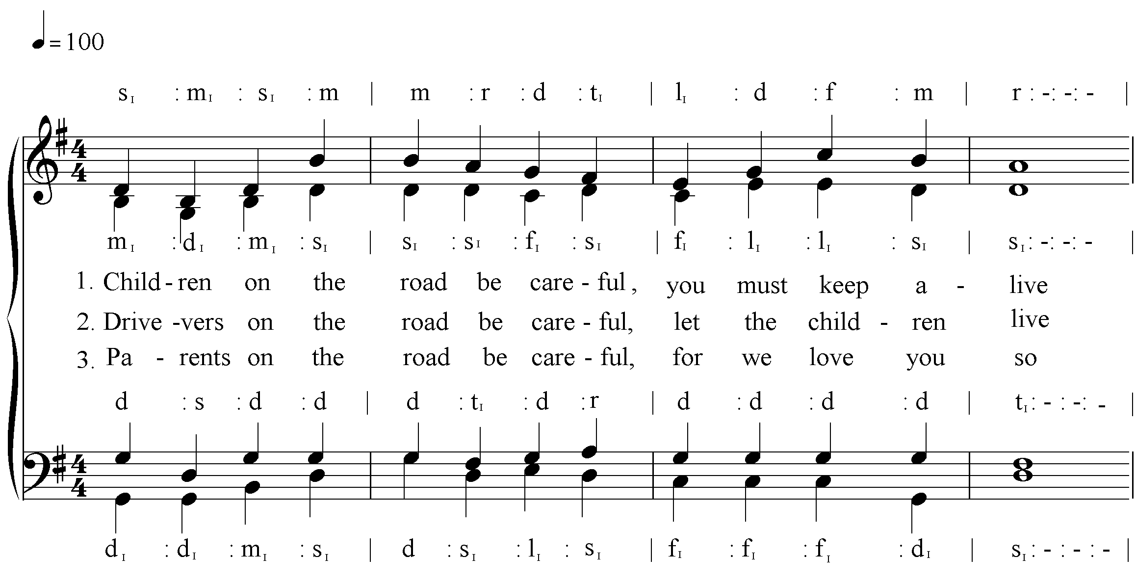
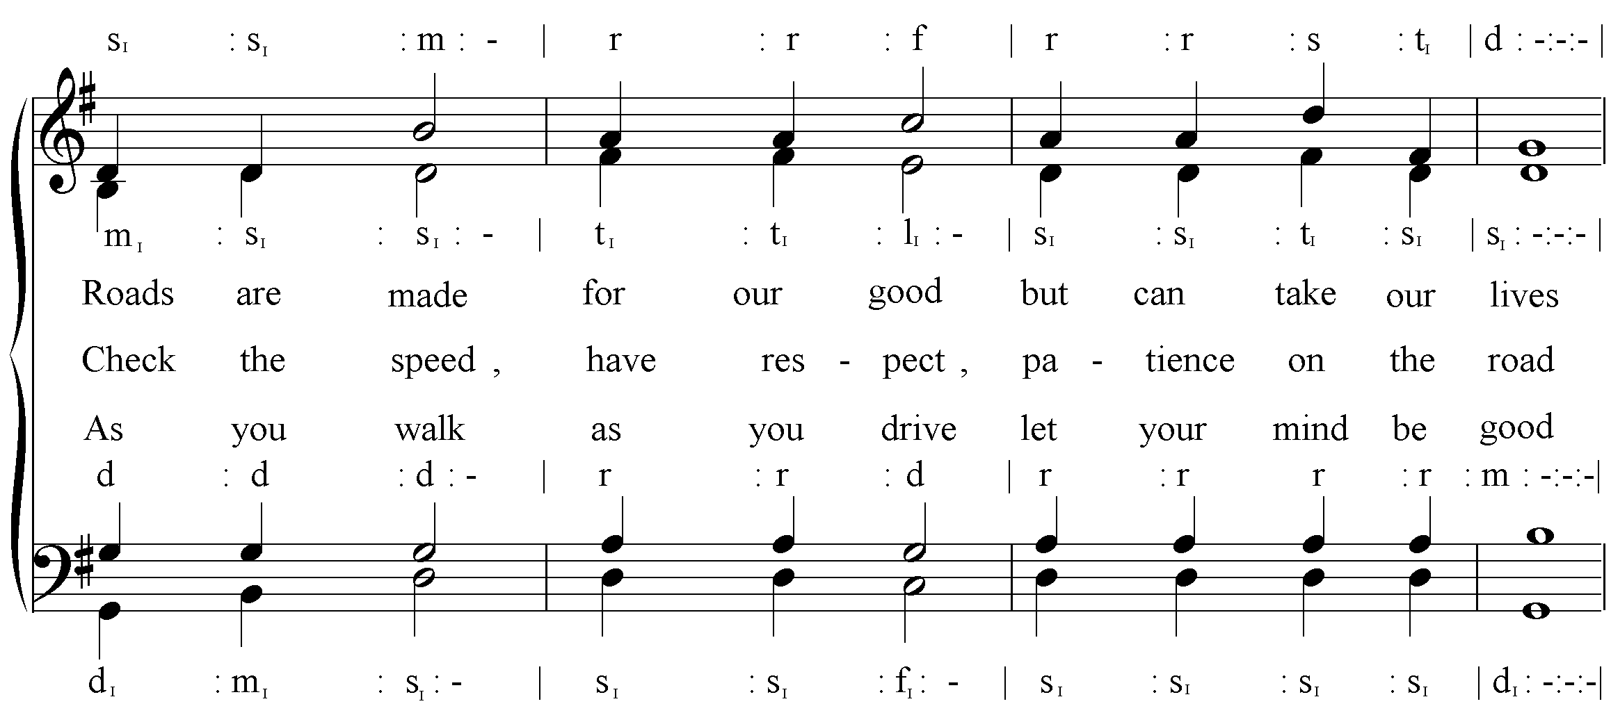
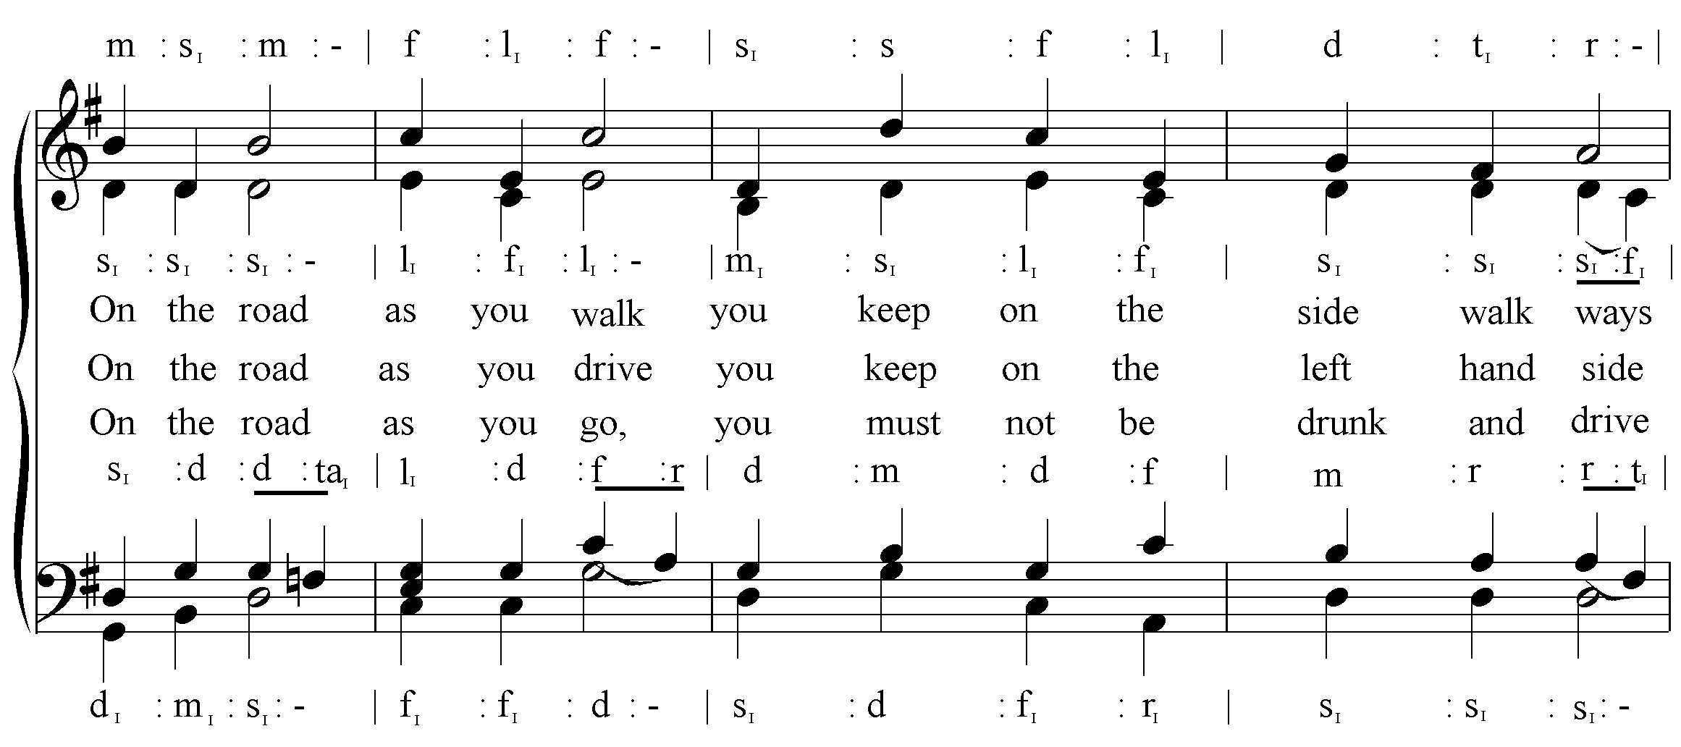
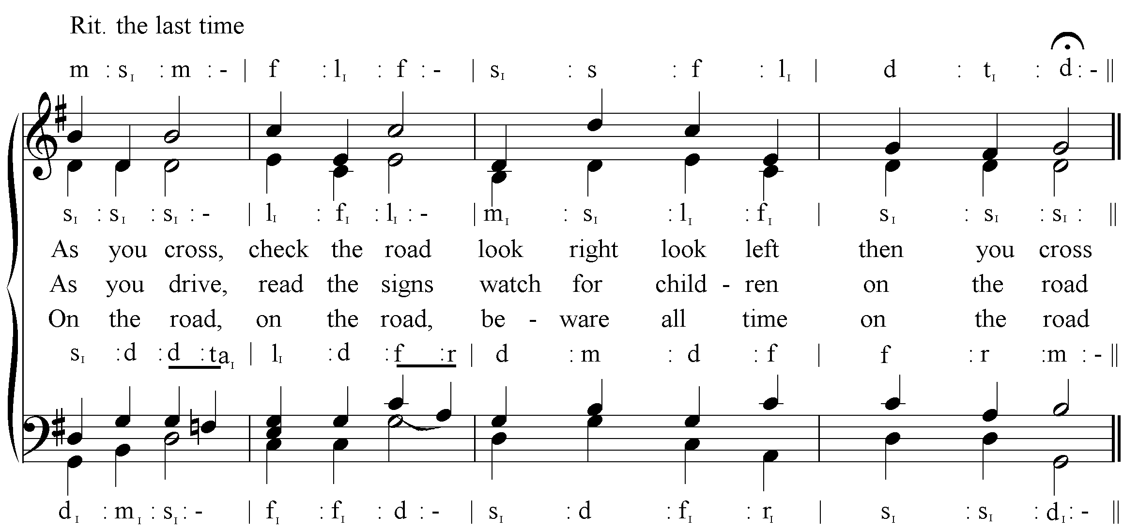

2.2. Difference between the Current and Past Initiatives
Previously, road safety interventions were focused on the drivers and less on the pedestrians. The Uganda Police Force has focused primarily on fining drivers and has not given much attention to the pedestrians. Similarly, road safety education has been non-existent except for some scattered content that is taught in Primary 6, and this falls under accidents.

The intervention has revolutionised road safety education through not only developing a curriculum but also through the creative ways in which it delivers that curriculum to the children. Before, road safety education was carried out at school assemblies through speeches and sensitisation only, but with the introduction of the road safety curriculum in schools, road safety is now taught in classes, practised during co-curricular activities, preached at every school assembly and sung every day at school.

2.3 Innovative Methods
Our innovative methods have been integrated at all levels of implementing this intervention, including the development of the project. For example, during the implementation of this RSE project, we composed the road safety song, which has become yet another anthem. We have established road safety clubs in schools which are a foundation for sustaining road safety education. As part of road safety education, the project initiated the school road safety competition at district level, which has gained momentum. Furthermore, innovative approaches like debates, quizzes and drama are being used to teach children about road safety.

3.0 Methodology

The need was also felt to bring policymakers on board so that they, too, could appreciate, promote and advocate for road safety in Uganda. The project’s purpose was to enhance safer road use behaviour in order to reduce and minimise the impact of injury and death caused by road accidents involving pupils in primary schools in Uganda. Schools needed to equip children with the knowledge and skills required to comprehend safe road use. They also needed resource materials to enable children to read about and understand road safety practices for safe road use. Teachers needed resource materials, training and exposure in road safety so that they are able to pass on the knowledge to school children. Rolling out road safety education needed funds to produce resource materials and the training of teachers to teach road safety in the schools. The need was also felt to reduce road accidents in order to cut down costs accruing from such accidents. The current cost of accidents in Uganda is at about 207bn/= and with the GDP of 11tn/= road accidents take about 1.88% of the national budget

3.1. Design of the Study

3.1.1 Extent and coverage of the project
The project was implemented in 180 primary schools in eight regions and 22 districts of Uganda with the following components:
- Road safety education forum: Forums were convened for the various stakeholders in Kampala for road safety education advocacy purposes.
- Development of trainer’s manual: A team of six road safety and curriculum development experts from URRENO and NCDC developed the manual.
- Training of 30 trainers: A team of 30 Centre Coordinating Tutors (CCTs) were selected from 10 Core Primary Teachers Colleges (PTCs) and trained.
- Training of classroom teachers: A total of 720 primary school teachers from the selected 180 schools were trained in teaching road safety.
- Re-printing and distributing of resource materials: The project produced and distributed a training manual, a teacher’s guide, a learner’s text, posters and a video to the target 180 schools in eight regions of Uganda.
- Monitoring and evaluation of the project: Monitoring and evaluation of project activities was done right from inception to the end.

3.2. Key Factors Considered
The key factors we considered in the project planning and implementation are shown below:
- Selection of schools: This was done with assistance from Ministry of Education and Sports and the Uganda Police Traffic and Road Safety Department. They advised us to target the schools in urban areas and those along the major highways.
- Primary 1-Primary 4 Road Safety Curriculum: We considered Primary 1-Primary 4 because they were the only grades for which a curriculum had already been developed though it had not been rolled out.
- Types of resource materials produced and distributed: The resource materials we produced for each school included four copies of teacher’s guides, three copies resource books, 36 pupil’s texts, four sets of wall charts and four DVDs. Though the government recommended a book-pupil ratio of 1:4, the road safety book-pupil ratio was about 1:9. That is why we had more wall charts, especially for Primary 1 and Primary 2.
- Teaching approaches to road safety: The teaching approaches we emphasised were role play, demonstration, explanation and discussion because the targeted pupils need simpler knowledge compared to those in higher classes for whom the brainstorming approach may be more effective.

3.3. List of Relevant Literature and Documents Reviewed
- The completion report of the World Bank-funded project, the Road Development Programme Phase 2 (PEMSIS) Project (June 2008), which recommended the roll-out of the road safety education curriculum.
- The Status of Road Safety for Uganda-2010, a report from the Ministry of Works and Transport, shows that there is need for rolling out road safety education among school- going children of Primary 1-Primary 4.
- The Annual Crime and Traffic/Road Safety Report of 2011, 2012 & 2013 by the Uganda Police Force attests that one out of every five road deaths in Uganda is a juvenile, i.e. under the age of 18, the age group where primary school children fall.
- Road safety audit and improvement study: Final Report Vol. I – V 2000: Phoenix Engineering and Research Ltd
- Ministry of Works and Transport Budget Policy Statement 2013/2014
- Overseas Road Note 17: Road safety Education in Developing countries Guidelines for good practice in Primary Schools TRL 1997

3. 4. Activities Work-plan

3.4.1 Road safety education forum
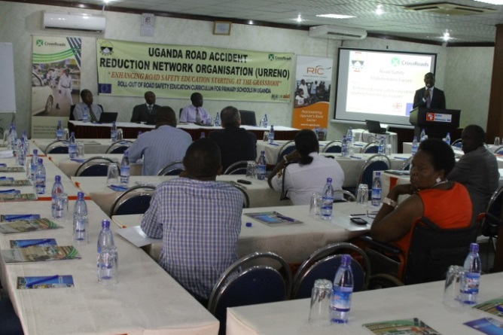
Road safety stakeholders’ forums were convened in Kampala and those invited to attend included NGOs, development partners and government ministries, i.e. the Ministries of Education, Works and Transport, and Health.
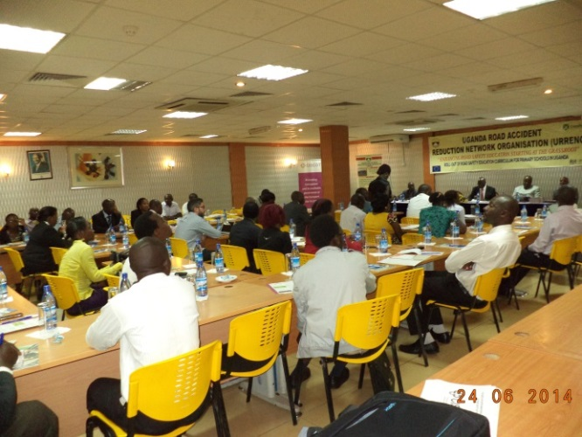
The purpose of the first forum was to launch the project and report on the baseline survey findings. The second forum was aimed at disseminating the project outcomes and the expected impact and advocates more interventions in road safety education. The monitoring team carried out an assessment of the participants’ reactions to the forum organisation. Two forums for road safety stakeholders were conducted in Kampala, one at the start of the project and the other at the end, and these forums involved participants from NGOs, development partners, the private sector and government ministries.

The purpose of these fora were to inform and educate participants about the problems created by road accidents and to bring many decision-makers and policy-makers on board so as to enable them to appreciate, promote and advocate road safety education in Uganda. Participatory and brainstorming approaches were used to come up with recommendations for the successful implementation of the project and to obtain future support for upscaling the interventions to cover the whole country.
In the first forum, recommendations were given to add value to the project implementation process and also to increase participation in and funding to road safety education in Uganda. The finalisation forum was to inform the participants about the achievements URRENO had attained in the concluded road safety education project. (Refer to Forum Reports dated 26th September 2013 and 24th June 2014.)

3.4.2 Training of trainers
The road safety education training workshop targeted 30 Centre Coordinating Tutors (CCTs) from various parts of the country who were drawn from 10 Core Primary Teachers College (PTCs) in 24 districts through a call for applications for a training-of-trainers (ToT) road safety course. The list of all trained CCTs is attached in annex 9.
The CCT’s were facilitated with transport refund depending on the distance travelled to and from training that was held at Green Valley Hotel in Ggaba from 19th to 22nd November 2013.

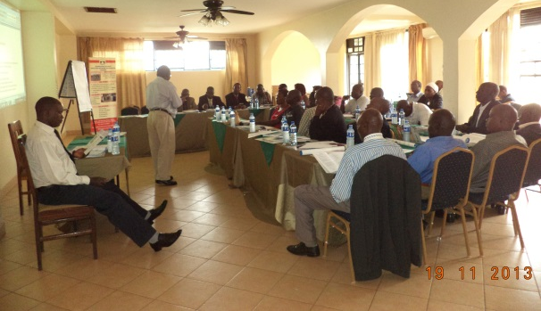
The five-day course took the format of participatory, instructional and demonstration approaches to train the CCTs in road safety education. A team of six road safety and curriculum development experts from URRENO and NCDC developed the trainer’s manual first and carried out the training of CCTs.

The development of the training manual involved reviewing and analysing the existing resource materials to ensure compliance and relevance to the Ugandan context. The manual would facilitate training of primary teachers in road safety by CCTs and would enhance the capacity of trainers to understand teaching road safety.

The training was based on the content of the training manual developed. The sessions of the training programme focused on: Background Information on Road Safety Education; Roads and Footpaths; Road Users; Safe Ways; Road Accidents; and Instructional Methods and Materials for Teaching Road Safety.

Each of the above sessions, had the following sub-topics: Competences, methods, materials, contents and procedures, which were all covered in varying time durations. In Session 8, the Road Safety Song was also taught.

3.4.3 Developing the trainers’ manual, printing and distribution of source materials
A team of six road safety and curriculum development experts from URRENO and NCDC developed the trainer’s manual. This involved reviewing and analysing the existing resources in Uganda to ensure compliance and relevance of this manual to the Ugandan context. The manual complemented the road safety resource materials, skills and knowledge available in schools. The project also produced/printed road safety materials as detailed earlier in this report. The distribution of the materials was done at two levels: 30 copies of Road Safety Education Trainer’s Kit were provided to 30 trainers at the training-of-trainers workshop and 180 Road Safety Education Resource Materials Kit at the 180 schools where the teachers were trained.

3.4.4 Training of teachers
A total of 720 primary school teachers from 180 schools were trained in their respective regions for three days. The training included the major contents of the training programme covered in the training of CCTs, which included: an introductory session; training objectives; competences, content and procedure; background information on road safety education; roads and footpaths; road users; safe ways; road accidents; instructional methods and materials for teaching road safety; and the way forward, which included learning the road safety song.
The teachers were facilitated with transport refund to and from the training that was held at the coordinating centre including meals and accommodation for 3 days.
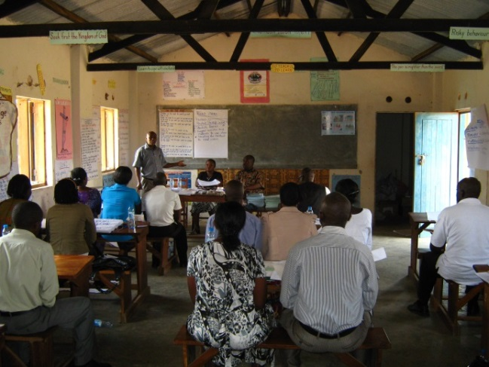
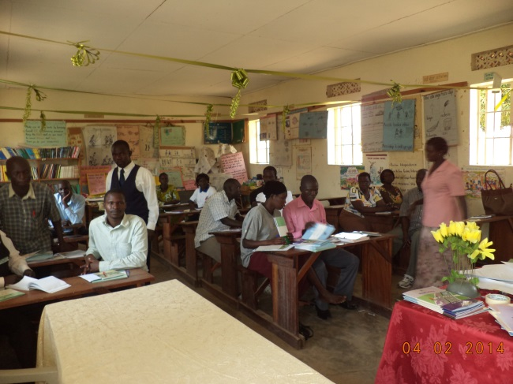

3.4.5 Teaching children road safety
The project taught about 65,000 pupils in 180 schools using participatory methods, including demonstration, role plays, music, dance and drama, and explanation and discussion. The project team composed a road safety song and taught it in all the schools; and we also conducted competitions in the schools that were ready during the project period.

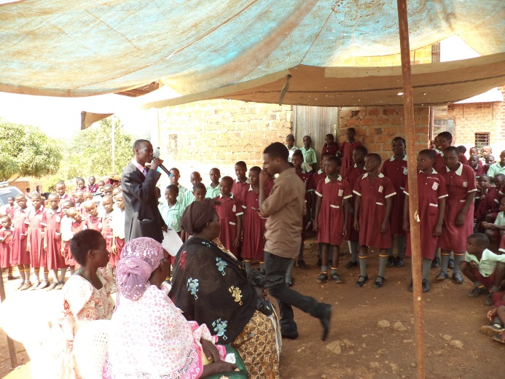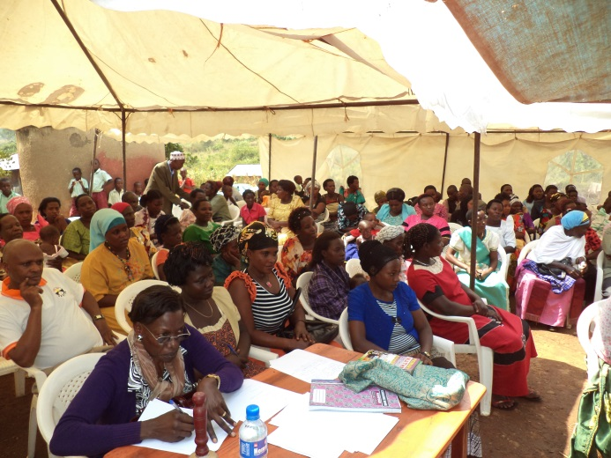

4.0 Presentation of Findings and Discussions

The project was rolled out to 180 schools, reaching out to 30 Centre Coordinating Tutors (CCTs) who were trained as trainers. As a result, 720 teachers from the 180 schools were trained by the CCTs. Each of the schools was represented by four teachers, of whom one had to be a member of school management (head teacher or deputy head teacher). The reason for having one of the teachers from school management to attend the training was to prepare for the sustainability of the efforts and to persuade the school to include road safety education in their teaching. At the time of the assessment of the project, the intervention had reached out to over 90,000 children in 180 schools countrywide.

Below is a detailed discussion of the results realised from each of the activities undertaken by URRENO and NCDC under this project.

Training of CCTs
A total of 30 CCTs were trained as trainers on road safety education. This training was successfully conducted in Kampala and involved the CCTs who are responsible for the 180 selected schools. It is at this training that the CCTs participated in the development of the road safety education song which was later produced by NCDC and URRENO and which has served as a creative tool to remind children about road safety. It is also through the training of these CCTs that the project has laid a firm foundation for road safety education since CCTs are responsible for regular monitoring and supervision of these schools. The CCTs have added road safety education to their checklist for supervision and enforcement.

Baseline Assessment for Teachers’ Training Needs
After the training of CCTs, a curriculum was available to be taught to the teachers from the 180 primary schools. Before the CCTs conducted the training, URRENO and NCDC conducted a needs assessment to establish what training approaches, content and context needed to be incorporated to ensure efficiency and effectiveness of the training. This baseline assessment was aimed at capturing the training needs of the teachers and the status quo at school level regarding road safety education in the targeted schools. The results from the baseline survey significantly informed the design and implementation of the training of the 720 teachers. The assessment was conducted in December 2013, among the sampled teachers in northern, western and central Uganda. A total of 73 teachers were interviewed and questionnaires administered in the course of collecting data.
According to the assessment, over 90% of the teachers interviewed had never received training in road safety. Also, over 98% of the teachers interviewed expressed interest in road safety training and further expressed the need to have such a curriculum in their schools which, they stated, had experienced road accidents involving not only children but the school staff as well. From the assessment, we noticed that whereas there was some content related to road safety in the mainstream curriculum of Primary 1 to Primary 4, this content did not have relevant teaching and reference materials and was passively taught in abstract form, hence leading to poor performance in road safety component. In addition, owing to the fact that road safety was part of the mainstream content, specific emphasis was not given to road safety, hence the crucial need for a customised road safety curriculum.
We also discovered in over 50% of the schools we visited had experienced road accidents. The causes of these accidents were predominantly linked to ignorance of the children and the carelessness of drivers. These accidents had occasionally led to the death of children and also school staff. In order for us to establish if road safety was given attention by school administrations, we inquired whether schools had road safety clubs, and if the school administration was giving any support to road safety. Over 95% of the schools we visited did not have road safety clubs and lacked support from the school administration. The teachers (over 95%) were interested in establishing road safety clubs in their schools and were optimistic that once these clubs were established, the school administration would be able to support them. The teachers further proposed some of the road safety areas they needed training in as outlined in the detailed baseline report attached.

Production of Road Safety Materials
A wide selection of road safety materials were developed by URRENO and NCDC, printed and distributed to 180 schools countrywide. From our monitoring exercises, we found these materials were being adequately used. The materials were produced ahead of the teacher training by the CCTs and during the training the teachers were given proper orientation on the use the materials. The materials include: 100 copies of the trainer’s manual; 720 copies of the teacher’s guide (1 to 4); 7,200 learner’s books (1 to 4); 720 copies of teacher’s resource books (P1 – P4); 8,100 poster and chart series; 864 copies of road safety DVDs (P1 - P2 & P3 – P4); 200 copies of the road safety song CD. From the assessment, we found that the materials were being put to good use although most schools indicated that the materials were not enough.

Training of 720 Teachers
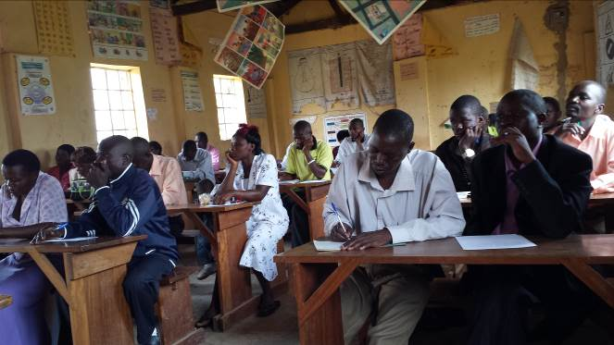
The CCTs trained 720 primary school teachers at 30 training locations countrywide. URRENO and NCDC staff participated at each of the training centres and at the end of each training workshop an evaluation was conducted.
The teachers appreciated the training, especially the participatory nature of content delivery. It was also at these training workshops that the road safety song was taught to the teachers by the CCTs. The teachers found the training approaches innovative and effective. We have attached a detailed evaluation report on the teacher training for more details. One of the key recommendations that emerged from the training of teachers was the need to create competitions at each centre so that the children could participate. Such competitions were later introduced by some CCTs, e.g. at Mubende. We found these competitions very creative in advancing road safety education.

Road Safety Advocacy Forums
The road safety forums were part of the project’s national level engagement with stakeholders. Two successful forums were conducted in Kampala, with the diverse and rich participation of the ministries of Education and Works, UNRA, the Uganda Police Force, as well as other members of civil society and the government. Among the policy issues debated was the recommendation to the government to speed up the establishment of a road safety authority. In addition, the Ministry of Education and Sports has been lobbied to emphasize road safety education in all the schools across the country. One significant achievement of these advocacy efforts is that, due to joint advocacy efforts targeted at UNRA, the organization has now issued a call for consultants to start working on road safety education on some of the new roads under construction. This project contributed significantly to this effort. We have attached two reports on the advocacy forums for more details.

URRENO Part of the CISCOT
URRENO together with other 24 Transport and Road Safety Organizations formed a coalition called, The Civil Society Coalition on Transport in Uganda (CISCOT) with funding from CrossRoads. URRENO’s participation in the formation of this coalition is a core milestone in enhancing efforts on road safety.

Road Safety Education in 180 Primary Schools Countrywide
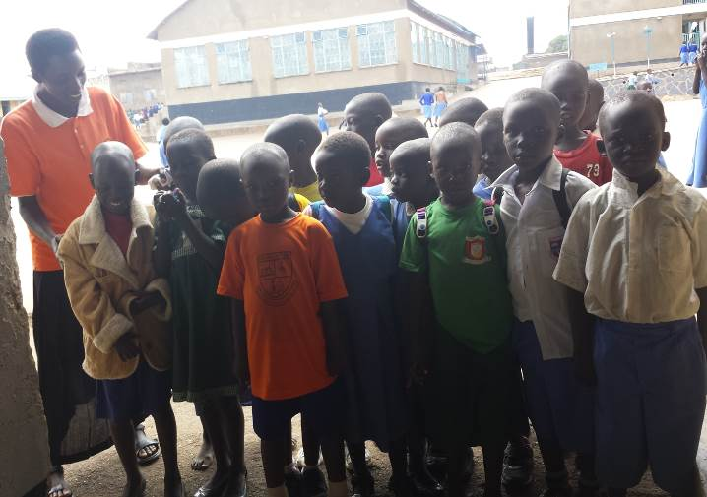
At the time of the assessment, the project had reached out to over 72,000 pupils countrywide. Immediately after the teachers and administrators were trained by the CCT, they went ahead and started teaching pupils.
In over 70 % of the schools we visited, the road safety song was the first item that had been taught to the pupils. In fact, almost all the schools presented the song at the general school assembly that brings together all the children. The majority of the schools sang this song twice a week, on Mondays and Fridays when they had the school assemblies. A demonstration of the road safety song was first given to the entire school by the trained teachers and the pupils later took over that role.

There are other creative ways in which the teachers passed on road safety education. For example, in Arua Public Primary School, the teachers taught the Primary 1 pupils a poem and a skit which they regularly presented to the entire school. In Arua and Mubende, for example, the CCTs had organised music, dance and drama competitions on road safety education. This had generated more debate and interest in road safety education not only among the pupils but also among the school administrators, this pilot of competitions presented a unique approach of educating learners.

In all the schools that we visited, the school administration was fully in support of the road safety education and of road safety activities in the school. In the majority of the schools, the head teacher had given the go-ahead for the establishment of the road safety clubs, which is one way to sustain interest among the school population. In the majority of the schools, the school administration allotted a slot in the school assemblies for a session/presentation on road safety. This was a clear demonstration of support by the administration to the intervention, which is a significant milestone in the sustainability of road safety education in the 180 schools.

In addition to these creative approaches to delivering road safety education to the pupils, the trained teachers have conducted formal classroom sessions/lessons on road safety. Other practical approaches have been used, e.g. demonstrating practically to the pupils how to cross the roads. According to some teachers, over 70% of the learners have demonstrated understanding of the subject. The teachers have witnessed significant change in the behaviour of children – e.g. the pupils no longer play on the roads; they walk on the right side of the road; and they have mastered the art of crossing the roads by looking left, then right, and then left again before crossing. In addition, teachers and head teachers informed us that they had witnessed the elder children helping the younger ones to cross the roods.

At the time of the assessment, it was too early to accurately assess the percentage reduction in the number of road accidents and incidents. We could only assess the change in behaviour of the learners and the effectiveness of the road safety education. More crucially, the materials that were distributed to the schools are being effectively utilised. For example, the posters were displayed and explained at the school assemblies in most of the schools.

Over 50 % of the schools engaged police officers, district engineers and parents in teaching the children at the school assemblies. In addition, some schools engaged the local council leaders, such as the LC1 chairperson, to speak to the children. The schools are continuing to explore more creative approaches to teaching road safety at all levels of learning in primary school. Some schools are using debates, songs and drama shows. We believe that it is this innovation and creativity that will impart knowledge and skills to the learners and hence reduce road accidents significantly.

Sustainability of Road Safety Education
The project’s sustainability plan was focused on engaging the school management to integrate road safety education in their school planning. This plan was mainstreamed right from project inception by having one of the school administrators as part of the four teachers who were trained per school. This strategy has yielded good results. In most of the schools we visited for evaluation, the school administrators were passionate about continuing the road safety education. Most of them have gone ahead and presented the idea to the Parents and Teachers Association, which has endorsed the integration of road safety in the schools’ activities.
Formation of road safety clubs is one of the strategies for sustainability of RSE in the schools trained. That’s why it’s important to support their establishment and operation.

Summary of Key Outputs
Key Output | Objectives Requirement
30 CCTs were trained | Increased road safety awareness, knowledge and skills among school children, teachers and Coordinating Centre Tutors (CCTs) in the target area
720 teachers from 180 schools were trained
Two forums were successfully concluded
All teachers have been trained, resource materials delivered and pupils are receiving the instructions
About 70,000 pupils are being trained
Children reported no accidents and told their teachers every morning about incidents such as playing on the road
A training manual was developed, printed and delivered | Road safety resource materials available for teachers and Primary 1- Primary 4 pupils in the target schools in Uganda
A teacher’s guide was printed and delivered to schools
Learner’s books were printed and delivered to schools
A teacher’s resource book was printed and delivered to schools
Posters were printed and delivered to schools
Videos were reproduced and delivered to schools
For all the schools that were evaluated no road accident was reported | Increased understanding of road safety and reduction in number of road accidents involving children
Children are conversant with road safety and can engage in debate and quiz
Completion forum recommendations to be complied and submitted to the government | Policy recommendations and support to enhance and advocate road safety education in Uganda
Every school has a road safety club but few have started on the relevant activities | Strong foundation established to sustain road safety education in target schools
The private schools have included a provision for co-curricular activities in their school budgets to cater for road safety clubs

From the above table, it is evident that the objectives that were set at the beginning of the project have been met.

5.0 Conclusions and Recommendations

5.1 Challenges

During the implementation of the project at all levels, a number of challenges were encountered. Below is a highlight of some of the challenges:
- During the implementation of the project, we realized that the materials produced were not enough to effectively cover all the schools.
- In fact, we also found that whereas the schools received CDs for the video and the songs, not all the schools had the equipment to use those CDs.
- In Primary 1 to Primary 4, most of the children learn better in their local languages and the teachers had to constantly translate the messages, which of course requires more time. There was, therefore, a need to translate some materials into the local languages.

5.2 Lessons Learned and Conclusions
It is clear from our research that the Ugandan government has not given road safety education adequate attention. However, we believe this is also due to the fact that there wasn’t any advocacy effort towards this cause. With the efforts from this intervention, we can see that road safety is beginning to get attention from the government. We realise that there is need for more effort to educate the public on road safety, especially drivers and riders. Basing on the lessons learnt from this project, we have realised that implementing road safety education and not educating the drivers would be doing just half the job.

The schools expressed passion and commitment to continue educating the learners on road safety and are calling upon the public to mind the children on the road. This calls for our intervention to not only focus on schools but also to reach out to the general public. The Uganda Police has also started road safety education in some schools and is willing to work with us in its promotion. We are strongly convinced that the schools that have benefited from this intervention will register a reduction in road accidents involving children. We learnt that road safety district music dance and drama competitions are a strong tool to educating road safety. There is need to continue this competition so that the government can appreciate its importance and take it up

5.3 Recommendations

It is very clear from the project that road safety education needs a lot of attention not only from the formal education institutions but also from parents and government agencies. In 2008, when URRENO, TRL and NCDC developed and implemented the road safety education curriculum, the focus was a lot more on formal education in the classroom. The following are the recommendation we have:
- The project emphasises that whereas there is a small component of road safety in the curriculum, teachers need more orientation so that they can effectively build and enrich the existing curriculum. It also points out the necessity to devote more material and audio-visual resources to the delivery of the road safety education curriculum.
- The environment has since changed drastically and, today, a holistic approach is required that involves both in-class teaching and out-of-class orientation. Discussions with teachers and education officers bear testimony to the fact that whereas it is very important to teach children about road safety, it is equally vital that efforts to implement safe driving on the roads are scaled up. For instance, these two categories of stakeholders emphasise the importance of raising road safety awareness in boda-boda riders and drivers of heavy goods vehicles.

The following were some of the responses we received at the completion forum held on 24th June 2014 at Hotel Africana:
- The Ministry of Education should partner with other stakeholders, such as URRENO, to incorporate road safety education into the school curriculum at all levels.
- It is vital that both teachers and pupils be continuously sensitised by URRENO, the Uganda Police Force and other road safety organisations as they provide first-hand information with regard to accidents in those communities.
- Workshops/seminars/conferences should be held across the whole country to increase awareness among the general public about road safety.
- More schools should set up road safety clubs and promote road safety education among the pupils.
- Parents and guardians should also be brought on board in the drive to fully sensitise pupils to road safety issues as some of them leave children to cross busy roads by themselves, ignoring the dangers to which the pupils are thus being exposed.
- Government should provide adequate road safety materials to school, including those in rural areas.
- The programme should be extended to secondary schools as students are vulnerable to accidents when they move to urban areas for further education.
- More teachers should be trained in road safety issues so that the normal transfer of teachers by the Ministry of Education does not affect the drive to curb road accidents.
- Schools should be registered as partners with road safety organisations to ensure the sustainability of the project and its impact as school admissions are a continuous process.
- Primary and secondary school teachers should undergo road safety instruction as part of their college or university training to ensure that their transfer and reassignment to other schools do not affect the sensitisation and flow of knowledge about road safety techniques.
- Ministry of Education should have more Centre Coordinating Tutors (CCTs) at district level oriented in road safety so that they are able to teach the in-service teachers.

Annexes

Inception Report

Baseline Report

First Stakeholders Forum Report

Second Stakeholders Forum Report

Training Needs Assessment Report

Teacher Training Report

List of teachers interviewed and schools visited during monitoring and evaluation

The number of children reached out by school and class

List of CCTs trained

List of teachers trained

List of materials produced

Photo gallery

The Log-frame

